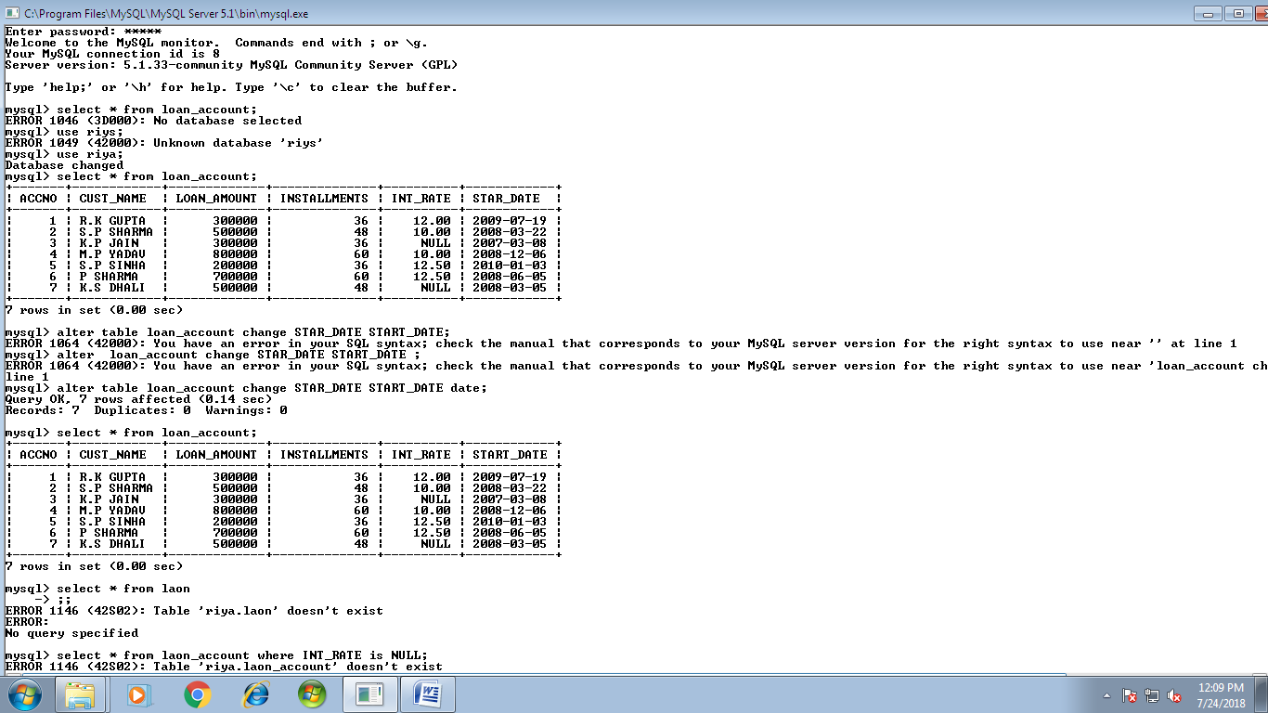**TABLE:LOAN_ACCOUNTS**

**QUERIES:-**

1. Display the details of all the loans whose rate of interest is NULL.
2. Display the details of all the loans with less than 40 installments.
3. Display the ACCNO and LOAN_AMOUNT of all the loan started before 01-04-2009.
4. Display the amount of various loan from the table LOAN_ACCOUNT. A loan amount should appear only once.
5. Display the number of installments of various loans from the table LOAN_ACCOUNTS. An installment should appear only once.
6. Display the details of all the loans started after 31-12-2008 for which the number of installments are more than 36.
7. Display the CUST_NAME and LOAN_AMOUNT for all the loans which do not have number of installments 36.
8. Display the details of all the loans whose rate of interest is in range 11% to 12%.
9. Display the CUST_NAME AND LOAN_AMOUNT for all the loans for which the number of installments are 24, 36 or 48(using in operator).
10. Display the details of all the loans whose LOAN_AMOUNT is in the range 400000 to 500000(using in operator).
11. Display the ACCNO, CUST_NAME and LOAN_AMOUNT for all the loans for which CUST_NAME contains ‘A’ as the second last character.
12. Display the details of all the loans in the descending order of their START_DATE.
13. Put the interest rate 11.50% for all the loans for which interest rate is Null.

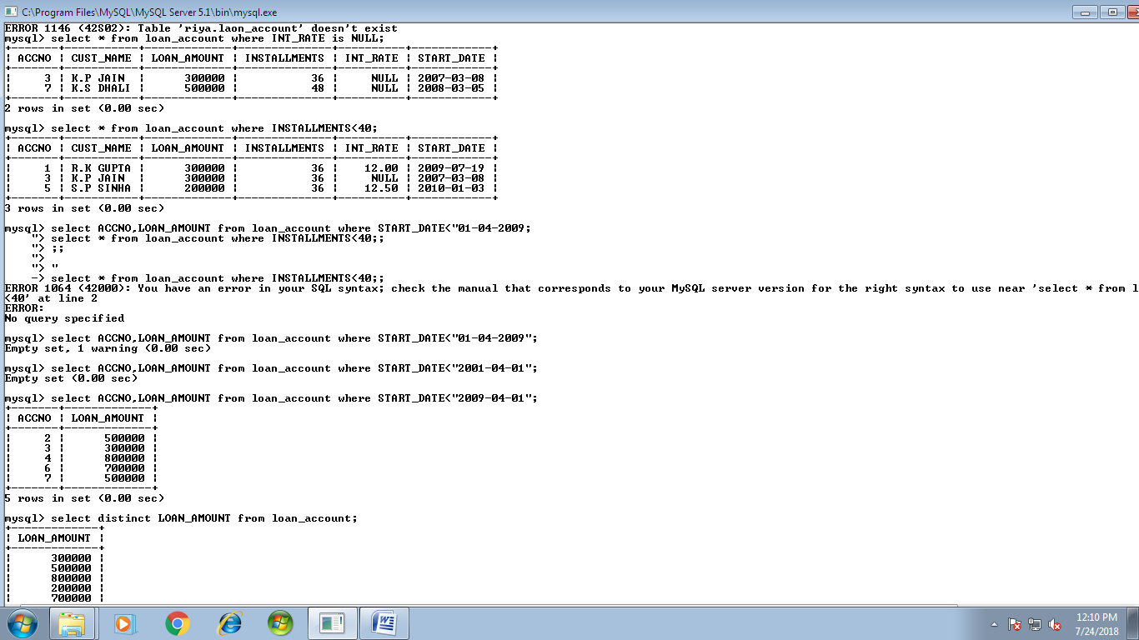**1.**

**2.**



**3.**

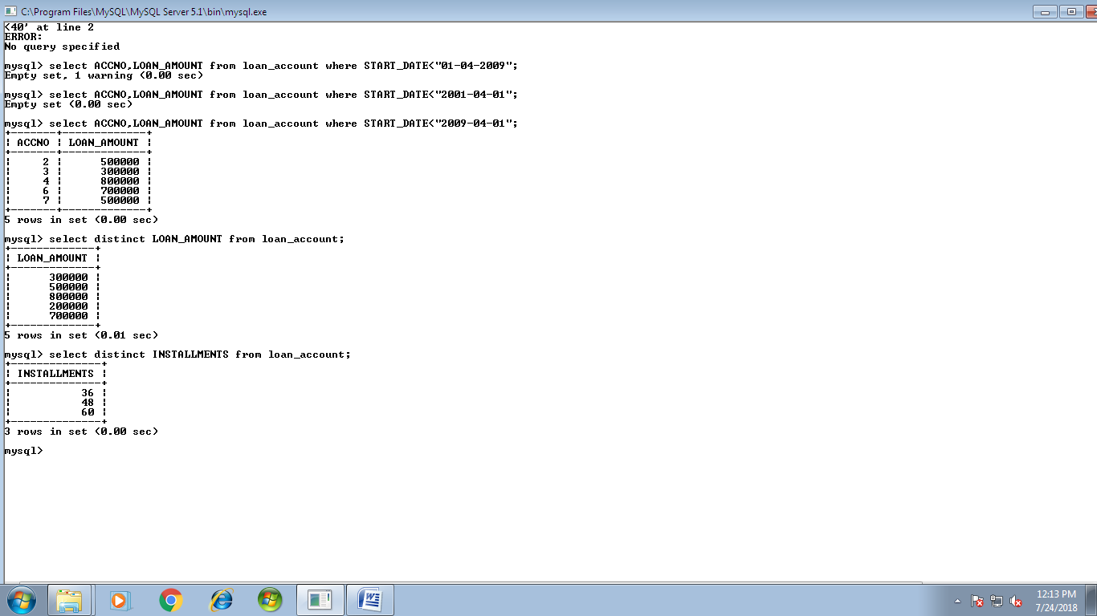**4.**

**5.**



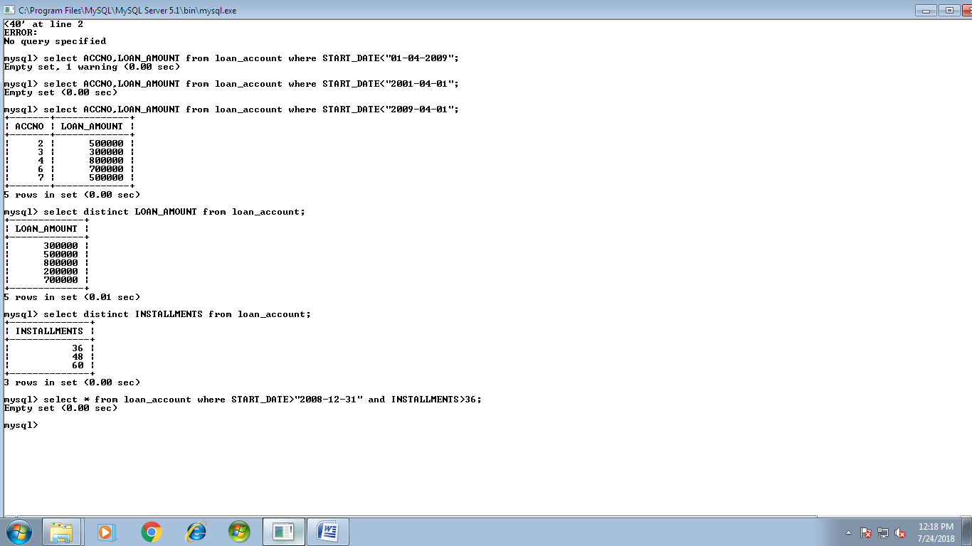**6.**

**7.**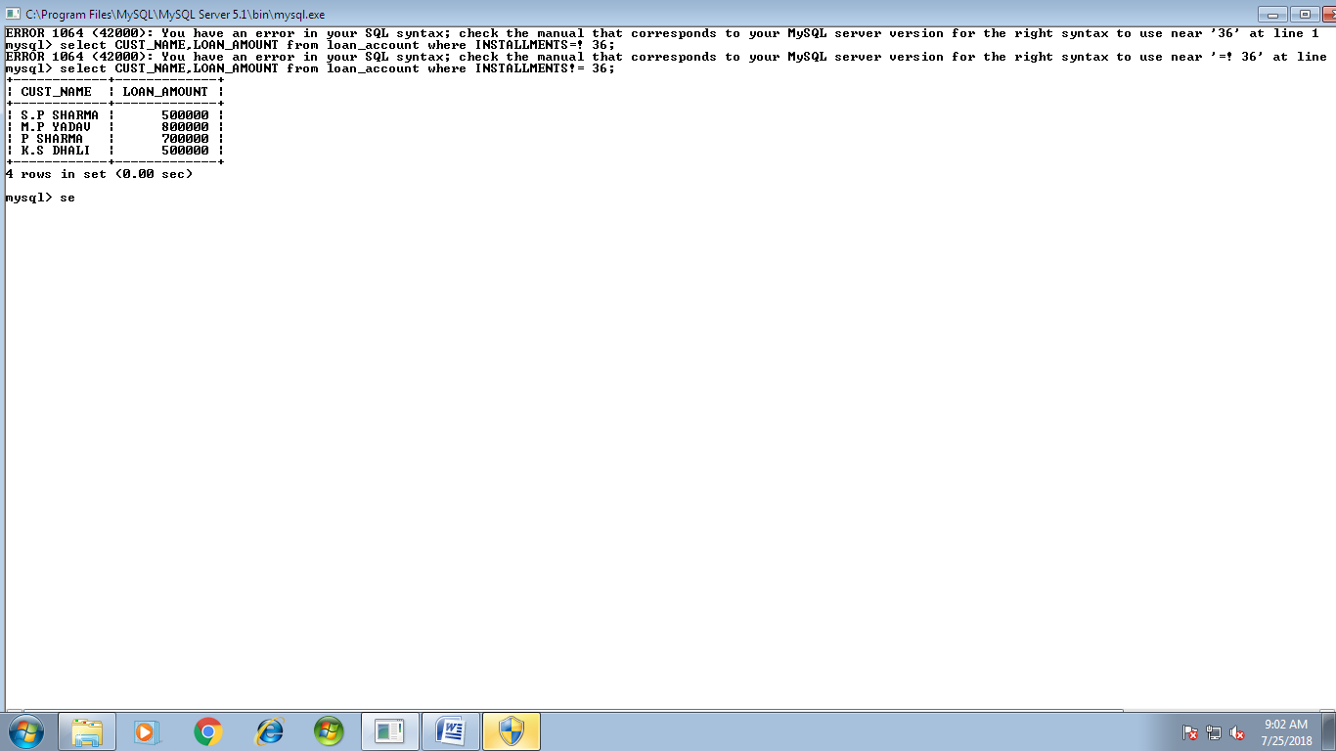

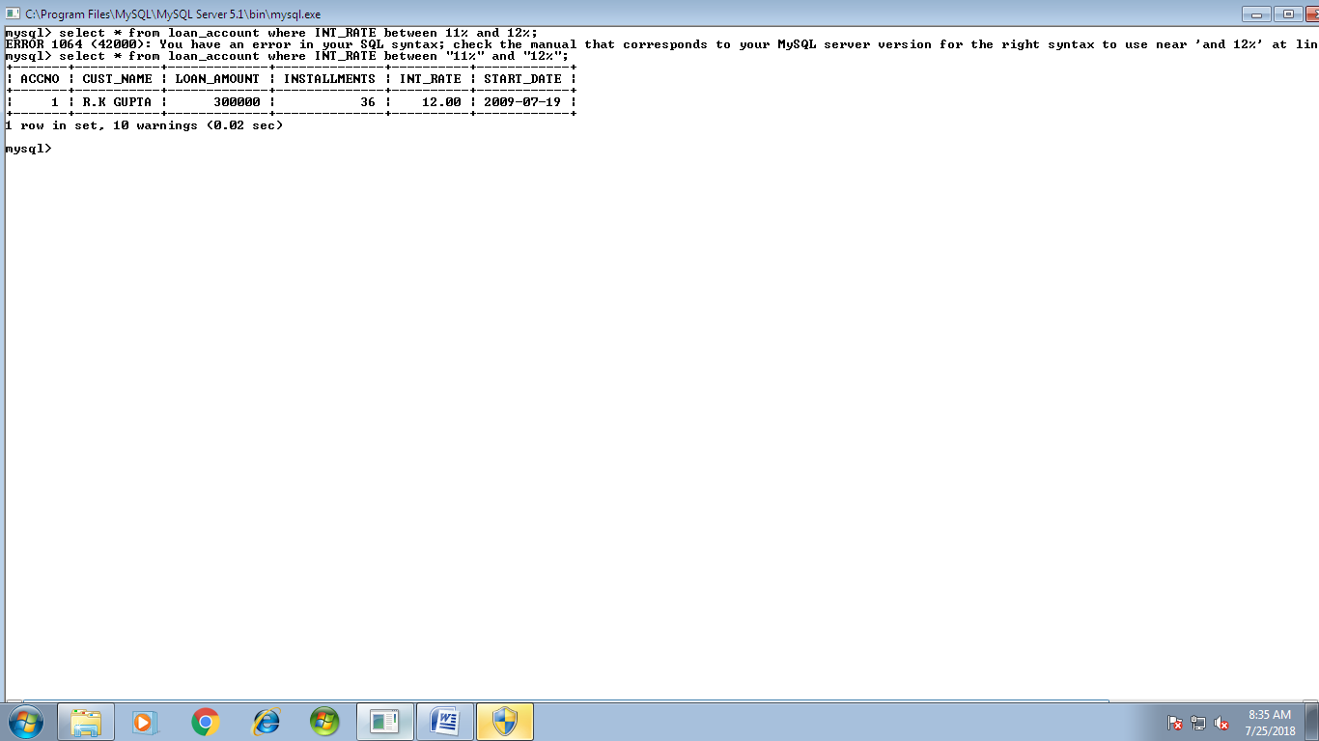**8.**

**9.**

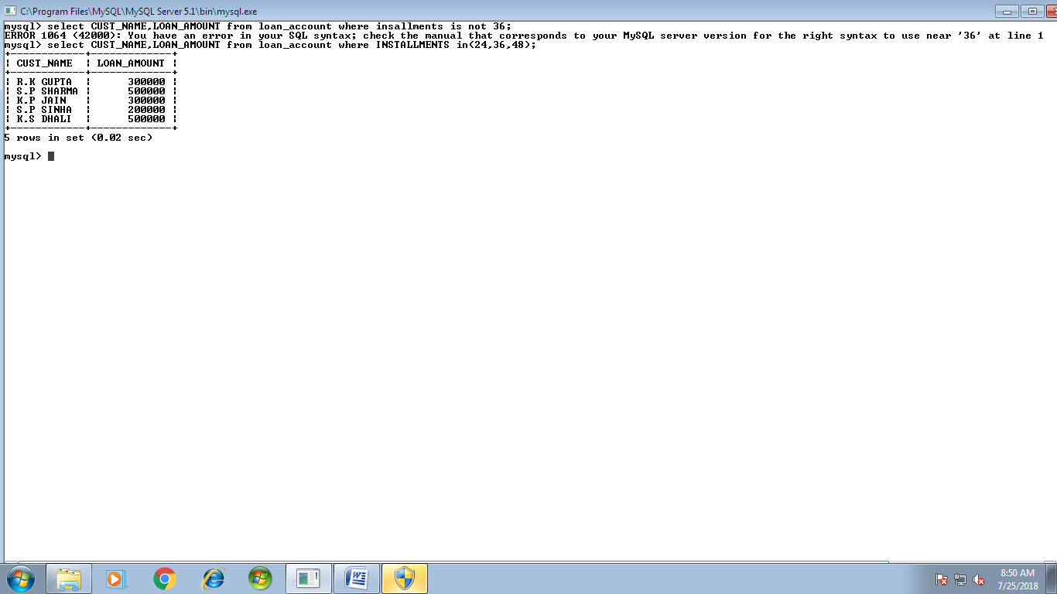

**10.**

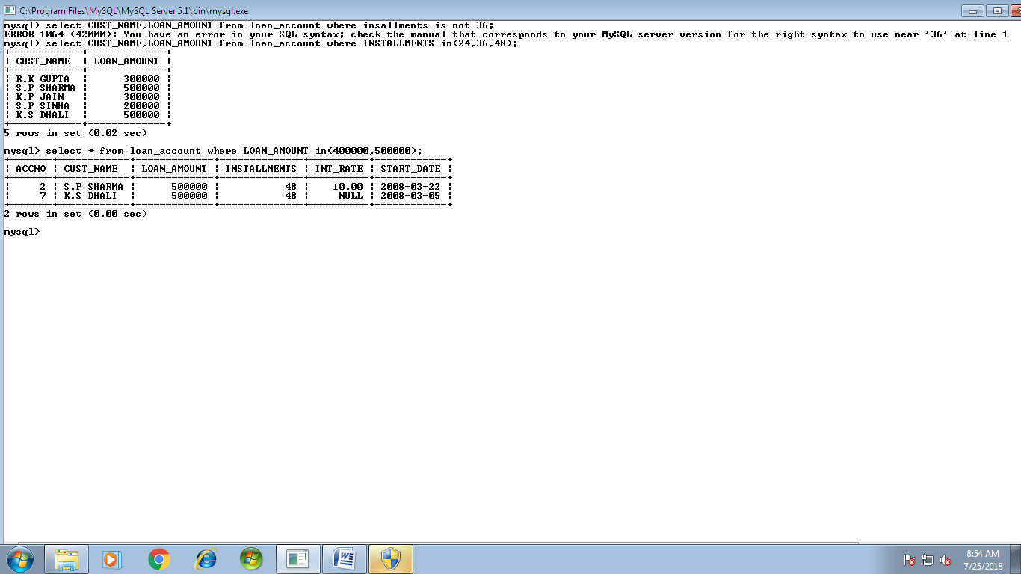

**11.**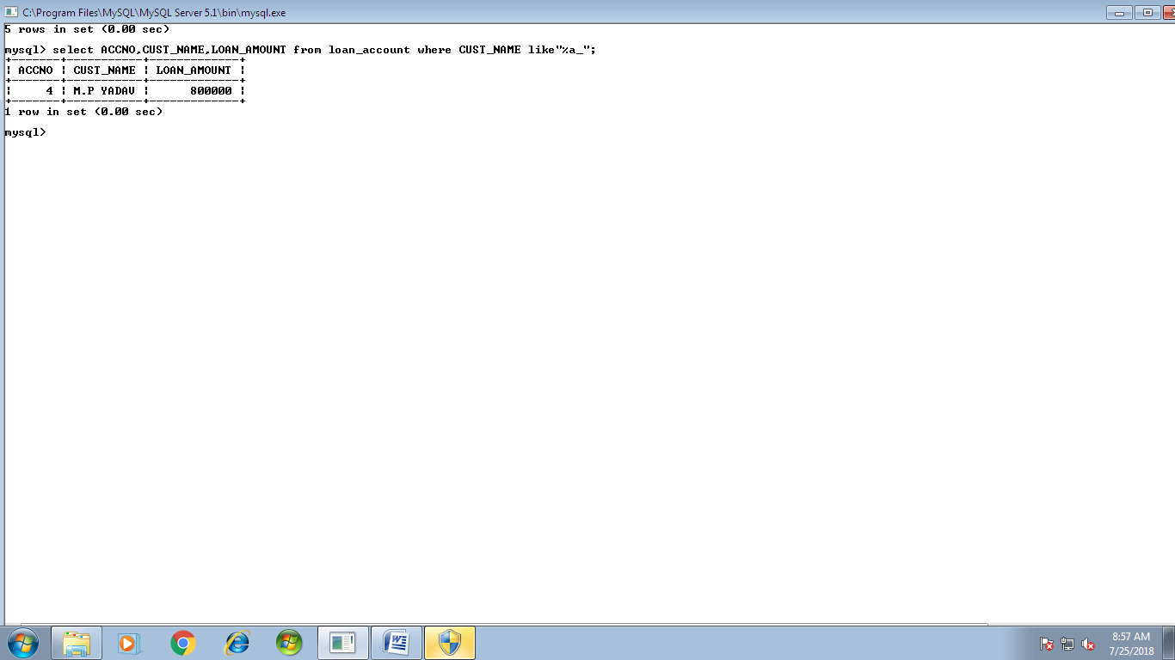

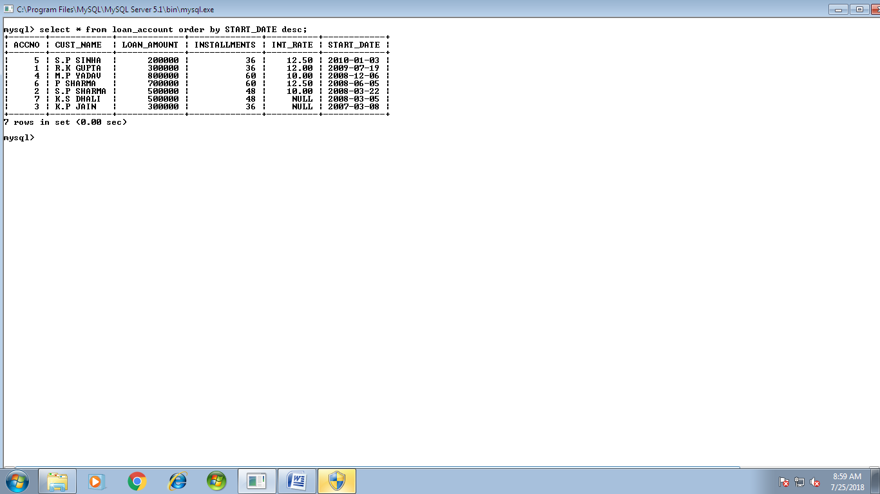**12.**

**13.**

